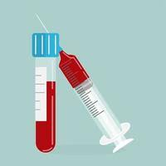**Dear Patient** 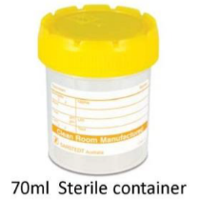

REPEAT TESTS

**PLEASE TRY NOT TO WORRY**

Please try not to be worried if you receive a text, phone call or letter requesting you repeat blood tests. The following information explains why we may request for tests to be repeated.

Please always bear in mind, if your test results could indicate serious disease that need a more urgent action, our admin team will contact you from our instruction to arrange for further assessment either by telephone or face-to-face

**OUT OF RANGE RESULTS**

Blood test results always come with what is called a reference range (also known as a normal range) the majority of test results are within this normal range. However on occasion, sometimes test results are slightly outside of this reference range.

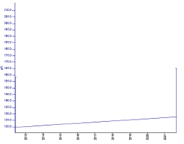In general this is not too concerning, however the Doctor who reviews your test results may ask for the test to be repeated in order to see how the trend is

Often we find results have reverted back to normal. Or the repeat test results show that the readings are stable, leading us to conclude that the results are likely to be normal for that individual and/or their medical conditions or medications taken.

**Explaining References Ranges**

Reference ranges provide the values to which your Doctor compares your test results to and determines your current health status. However, the true meaning of a test result—whether it indicates that you are sick or well or at risk for a health condition—can only be known when all the other information your provider has gathered about your health, including the results of a physical exam, your health and family history, recent changes in your health, any medications you are taking, and other non-laboratory 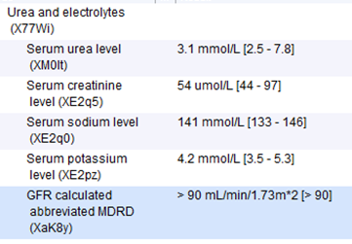testing. usually the values that the are between two standard deviations from the average

**INCONCLUSIVE RESULTS**

Test results are not always 100% accurate. Sometimes, test results come back inconclusive. A common example of this is urine testing, where no one single bacteria is identified as being the cause of the problem. In these cases, if you still have symptoms, we may repeat the test and see if it comes back showing a definite result. On rare occasions, tests may need to be repeated several times to see the underlying trend. Please do not be alarmed if this is the case.

**UNLABLELLED SAMPLES Do Don’t**

This is an extremely common and very frustrating reason for having to repeat tests, yet completely avoidable. If any sample does not carry as a minimum, name and date of birth, then the lab simply will not touch it. Therefore when dropping back samples to us, such as urine or stool bottles, please make sure that you have labelled all sample bottles with your name, date of birth, type of sample, date of sample and if there is space for it, the first line of your address.

We now have facilities to print labels for sample bottles and/or swabs, therefore if you have collected or dropped off a bottle or swab from the front desk, but it does not yet have a label, please feel free to ask our receptionist to print off a label for you to attach to the bottle.

**SAMPLING ERRORS**

Sometimes, test results indicate there were problems with the actual testing of the sample or other sampling problems, such as too small a urine sample provided, problems with laboratory equipment, or wrong bottle being used for the type of blood test. This will mean that the test will need to be repeated.

**OTHER TESTS**

Sometimes, results bring up something that requires some new or different tests in order to shed some further light on what could be happening with you. Again, please try not to worry if this is the case. The doctor will have decided that such testing is appropriate, based on the result and their prior assessment of your condition.

**CONCLUSION**

Hopefully this page will have come some way to explaining things for you so that you do not worry unnecessarily. As indicated in the red message box above, if something urgently serious is going on, we will always get in touch with you directly.

Yours sincerely  
Bryn Cross Surgery